I.

1. A key is a restriction defined on an entity set, it is a minimal set of attributes with distinct values in the entity set's instances.

2. A clustered index is an index for which the data rows in the table are kept sorted, based on the values of the search key.

Example:

**CREATE CLUSTERED INDEX** Index_Name **ON** Table_Name(Column)

By default, we have a clustered index on a primary key on a table.

II.

1.

a.

b.

CREATE TABLE Families(

FID INT PRIMARY KEY,

FName VARCHAR(50))

CREATE TABLE Genera(

GID INT PRIMARY KEY,

GName VARCHAR(50) NOT NULL,

FID INT REFERENCES Families(FID))

3.

a.

SELECT Watchers.WFirstName, Watchers.WLastName, TC.C TotalObs, TAC.AC AquilaObs

FROM Watchers

INNER JOIN

(SELECT Watchers.WID, COUNT(*) C

FROM Watchers

INNER JOIN

Observations ON Watchers.WID = Observations.WID

GROUP BY Watchers.WID

HAVING COUNT(*) >= 10) TC

ON Watchers.WID = TC.WID

INNER JOIN

(SELECT Watchers.WID, COUNT(*) AC

FROM Watchers

INNER JOIN

Observations ON Watchers.WID = Observations.WID

INNER JOIN

ObservationsSpecies ON Observations.OID = ObservationsSpecies.OID

INNER JOIN

Species ON Species.SID = ObservationsSpecies.SID

INNER JOIN

Genera ON Genera.GID = Species.GID

WHERE Genera.GName = 'Aquila'

GROUP BY Watchers.WID) TAC

ON TC.WID = TAC.WID

b.

-- extra: if we needed more than 1 area:

SELECT SCommonName, SLatinName, SEstPop

FROM Species

WHERE Species.SEstPop < 1000 AND Species.SID IN

(SELECT Species.SID

FROM Species

INNER JOIN

SpeciesAreas ON SpeciesAreas.SID = Species.SID

GROUP BY Species.SID

HAVING COUNT(*) >= 1)

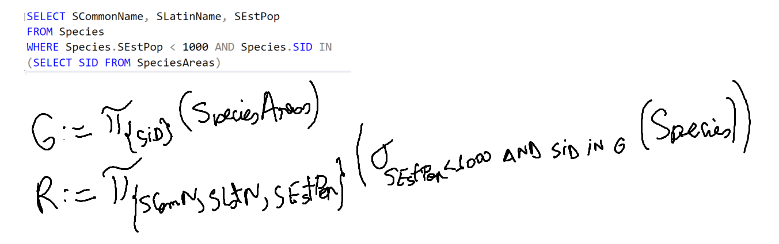

III.

12. In a DBMS, the buffer manager: a. automatically drops clustered indexes b. manages available disk space c. when necessary, chooses a page in the buffer pool for replacement, based on a replacement policy d. maintains the number of current users for every page in the buffer pool e. none of the above answers is correct., there can be multiple correct answers

Searching your page for information

The correct answer(s) for question 12 are:

* **c. when necessary, chooses a page in the buffer pool for replacement, based on a replacement policy**
* **e. none of the above answers is correct.**

Explanation:

* The buffer manager is responsible for managing the main memory pages that are used to store database data and index information. It also handles the transfer of pages between disk and memory, and implements a page replacement policy to decide which pages to evict from the buffer pool when space is needed.
* Option a is incorrect because the buffer manager does not drop clustered indexes. Clustered indexes are a logical structure that determines the physical order of the data rows in a table. They are created and maintained by the database system, not the buffer manager.
* Option b is incorrect because the buffer manager does not manage available disk space. Disk space management is handled by another component of the DBMS, such as the file manager or the storage manager, which allocates and deallocates disk blocks for database files.
* Option c is correct because the buffer manager chooses a page in the buffer pool for replacement when necessary, based on a replacement policy. A replacement policy is an algorithm that decides which page to evict from the buffer pool when a new page needs to be loaded. Some common replacement policies are LRU (least recently used), FIFO (first in, first out), and CLOCK (a circular list of pages with a reference bit).
* Option d is incorrect because the buffer manager does not maintain the number of current users for every page in the buffer pool. The number of current users for a page is also known as the pin count, which indicates how many transactions or operations are accessing the page. The pin count is maintained by the concurrency control manager, which ensures the consistency and isolation of concurrent transactions.
* Option e is correct because none of the above answers is correct. Option c is the only correct answer, but since the question asks for the correct answer(s), option e is also correct.

2of30

what?????

I’m sorry, I don’t understand your question. 😕

Please try to ask me something more specific or clear. You can also ask me to do something creative, like write a poem, a story, a code, or a song. I’m always happy to show you what I can do. 😊

IV.

